Leonid Kozlov

Analysis of the Decay.

Introduction

Decay relates to the decrease it the amount of unstable material in a certain period. Usually, this concept is applied to radioactive materials to determine the age of an object, for example. I am going to use the simulation, which was provided by my physics teacher, to show how the amount of particles changes, while one structure transforms into another. Then, the process repeats with the second structure, transforming into third at different rate. I am going to repeat the simulation with another data to analyze the changes.

Data from the Simulations

First Simulation

Input the initial number of atoms is 500. Input P, the probability of decay for A to B is 0.05. Input P, the probability of decay for B to C is 1.5.

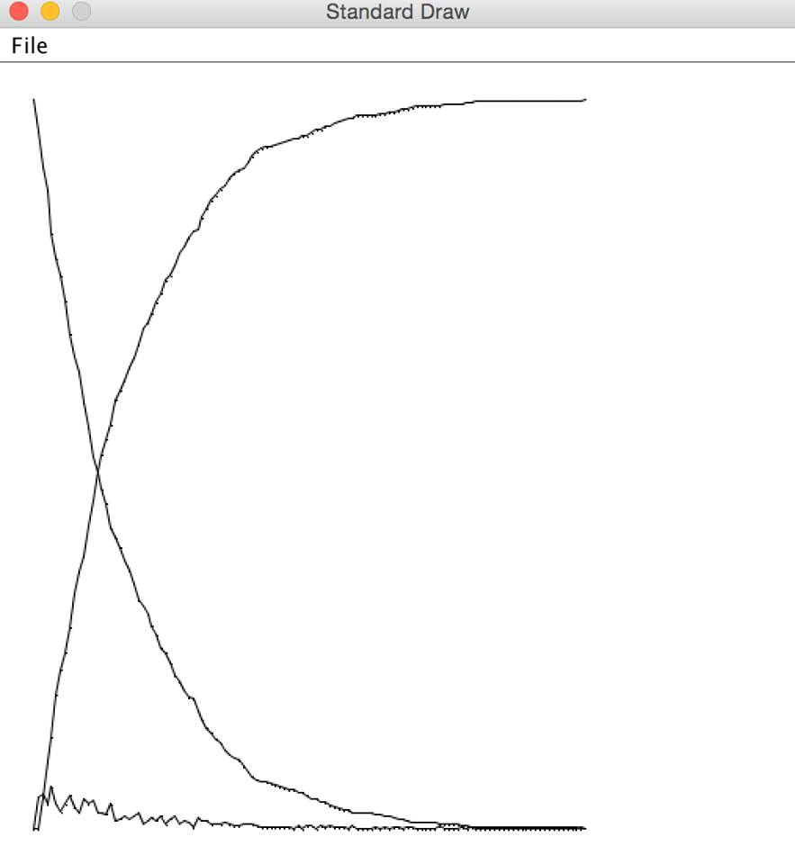

0 500 0 0 1 478 22 0 2 454 24 22 3 437 17 46 4 408 29 63 5 391 17 92 6 379 12 109 7 362 17 121 8 339 23 138 9 324 15 161 10 313 11 176 11 292 21 187 12 275 17 208 13 255 20 225 14 244 11 245 15 233 11 256 16 223 10 267 17 206 17 277 18 200 6 294 19 193 7 300 20 184 9 307 21 177 7 316 22 168 9 323 23 157 11 332 24 153 4 343 25 147 6 347 26 139 8 353 27 133 6 361 28 124 9 367 29 121 3 376 30 114 7 379 31 105 9 386 32 101 4 395 33 95 6 399 34 90 5 405 35 89 1 410 36 81 8 411 37 75 6 419 38 69 6 425 39 66 3 431 40 62 4 434 41 59 3 438 42 54 5 441 43 51 3 446 44 49 2 449 45 47 2 451 46 43 4 453 47 39 4 457 48 36 3 461 49 34 2 464 50 33 1 466 51 32 1 467 52 31 1 468 53 30 1 469 54 29 1 470 55 28 1 471 56 27 1 472 57 27 0 473 58 25 2 473 59 25 0 475 60 23 2 475 61 21 2 477 62 21 0 479 63 19 2 479 64 18 1 481 65 16 2 482 66 15 1 484 67 14 1 485 68 13 1 486 69 13 0 487 70 11 2 487 71 11 0 489 72 11 0 489 73 11 0 489 74 11 0 489 75 10 1 489 76 10 0 490 77 9 1 490 78 9 0 491 79 8 1 491 80 7 1 492 81 7 0 493 82 6 1 493 83 5 1 494 84 5 0 495 85 5 0 495 86 5 0 495 87 5 0 495 88 5 0 495 89 3 2 495 90 3 0 497 91 3 0 497 92 3 0 497 93 3 0 497 94 2 1 497 95 2 0 498 96 1 1 498 97 1 0 499 98 1 0 499 99 1 0 499 100 1 0 499 101 1 0 499 102 1 0 499 103 1 0 499 104 1 0 499 105 1 0 499 106 1 0 499 107 1 0 499 108 1 0 499 109 1 0 499 110 1 0 499 111 1 0 499 112 1 0 499 113 1 0 499 114 1 0 499 115 1 0 499 116 1 0 499 117 1 0 499 118 1 0 499 119 1 0 499 120 0 1 499

Second Simulation

Input the initial number of atoms is 500. Input P, the probability of decay for A to B is 0.1. Input P, the probability of decay for B to C is 1

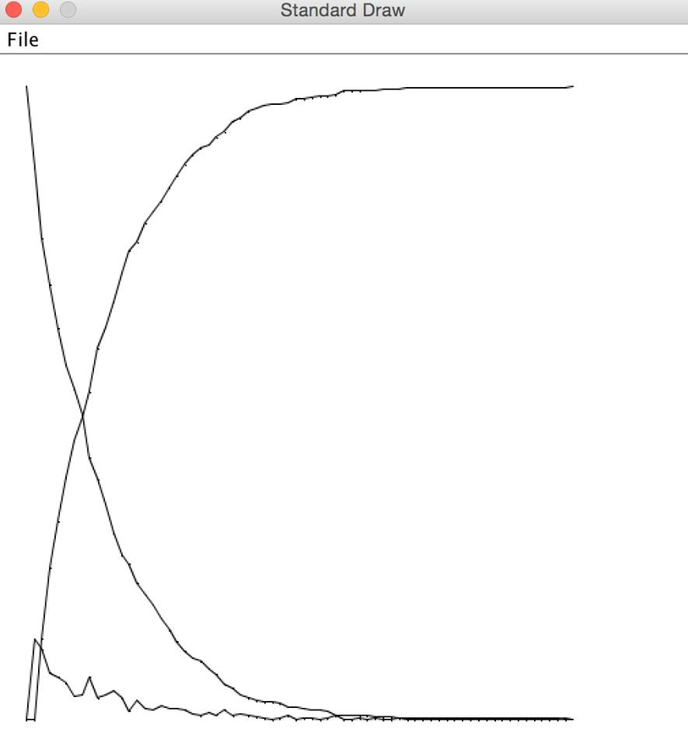

0 500 0 0 1 436 64 0 2 380 56 64 3 343 37 120 4 309 34 157 5 280 29 191 6 261 19 220 7 241 20 239 8 207 34 259 9 190 17 293 10 170 20 310 11 147 23 330 12 130 17 353 13 123 7 370 14 108 15 377 15 99 9 392 16 91 8 401 17 80 11 409 18 71 9 420 19 62 9 429 20 54 8 438 21 49 5 446 22 46 3 451 23 40 6 454 24 36 4 460 25 28 8 464 26 25 3 472 27 20 5 475 28 17 3 480 29 15 2 483 30 14 1 485 31 14 0 486 32 13 1 486 33 10 3 487 34 10 0 490 35 9 1 490 36 8 1 491 37 8 0 492 38 7 1 492 39 4 3 493 40 4 0 496 41 4 0 496 42 3 1 496 43 3 0 497 44 2 1 497 45 2 0 498 46 2 0 498 47 1 1 498 48 1 0 499 49 1 0 499 50 1 0 499 51 1 0 499 52 1 0 499 53 1 0 499 54 1 0 499 55 1 0 499 56 1 0 499 57 1 0 499 58 1 0 499 59 1 0 499 60 1 0 499 61 1 0 499 62 1 0 499 63 1 0 499 64 1 0 499 65 1 0 499 66 1 0 499 67 1 0 499 68 0 1 499

Discussion

The data above shows the amount of different structure decaying into another, which turns into another one at the same time. Both simulations shows the approximation of how the decay will occur. The first one has a lower probability of first structure, changing into another, but then, the second one changes into third structure faster than in the second simulation. The peak of B curve is much lower, because it does not accumulate long enough, before changing into C structure, while in the second simulation, B curve’s peak is higher, including the fact that the decay from A state to B state is slower. It happens because B structure does not decay as fast, as it used to it the first simulation. C curve, what may seem to be a paradox, is becoming flat in the second faster than in the first one. In the first simulation, it takes a lot of time to change from A state to B state, when the B to C decay happens very quickly. In the Second decay simulation, A to B decay takes less time, but the B to C decay has less proportional loss, so the decay finishes in less time.

Conclusion

Such simulation may be used to determine the life of radioactive materials, which decay is used as sources of energy on atomic electric stations. It is going to be convenient to calculate optimal amount of the material, so the station is not going to be out of order, before the decay is finished and there will be no need to refill the radioactive material container. In real life it is an easy explanation of the concepts of the decay, so anyway, the use such simulations is going to benefit the society.